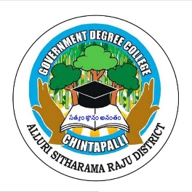
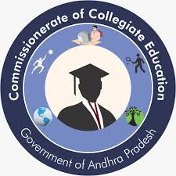
Government Degree College, Chintapalli
Affiliated to Andhra University
Chintapalli, Alluri Sitharama Raju -District, AP.

Phone no: 9666739207. Email.ID: gdcchintapalli@gmail.com

GUEST LECTURES
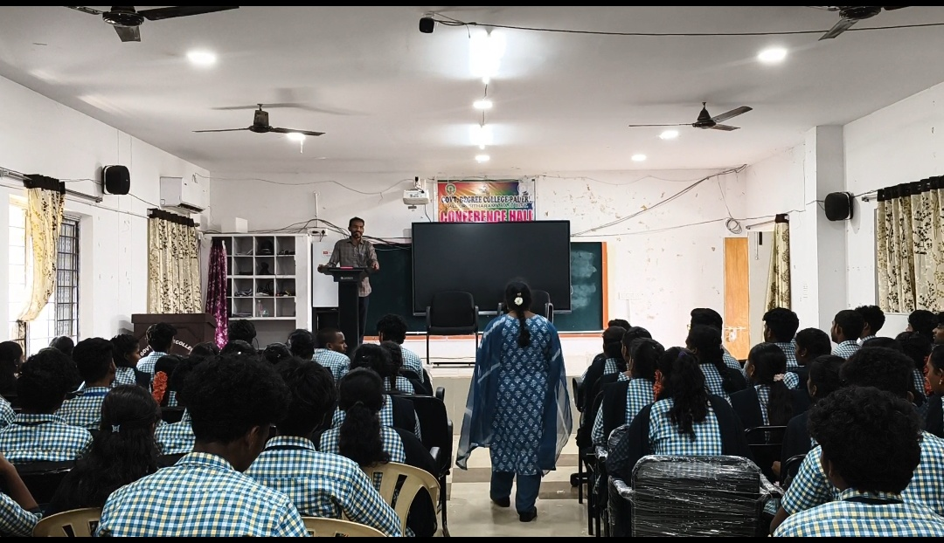

Guest Lecture by P. Ramaraju at GDC Paderu
A guest lecture was organized at Government Degree College (GDC), Paderu, featuring Sri P. Ramaraju, Lecturer in Commerce from Government Degree College, Chintapalli. The session aimed to enrich students’ understanding of core commerce concepts and provide practical insights into the subject.
Sri P. Ramaraju is a dedicated faculty member known for his expertise in Commerce and his student-friendly teaching approach. During the session, he delivered an informative and engaging lecture on key topics such as fundamentals of commerce, business environment, and the importance of financial literacy in today’s world. He also highlighted emerging trends in commerce, including digital transactions, entrepreneurship, and the role of commerce in economic development.
The lecture was highly interactive, with students actively participating and raising questions. Sri P. Ramaraju encouraged students to think critically and apply theoretical knowledge to real-life situations. He also shared valuable guidance on career opportunities in commerce, including fields like accounting, banking, taxation, and business management.
The faculty members and students of GDC Paderu appreciated the clarity and relevance of the lecture. The session helped students gain a deeper understanding of the subject and motivated them to pursue higher education and career opportunities in commerce.

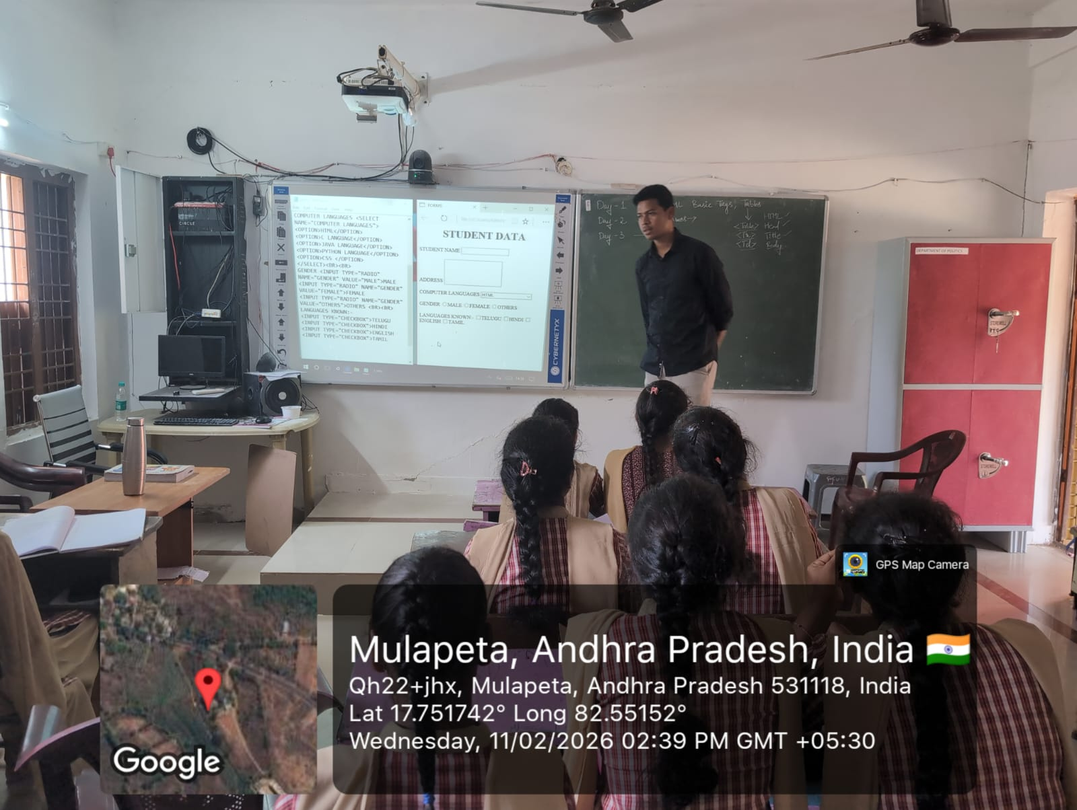
GUEST LECTURE

Guest Lecture by T. Satya Vara Prasad at GDC Marripalem

A guest lecture was successfully organized at Government Degree College (GDC), Marripalem, featuring Sri T. Satya Vara Prasad, Lecturer in Computer Applications from Government Degree College (GDC), Chintapalli. The session was conducted with the objective of enhancing students’ knowledge in the field of computer applications and exposing them to current technological trends.
Sri T. Satya Vara Prasad is well known for his expertise in computer science and his practical approach to teaching. During the lecture, he covered important topics such as fundamentals of computer applications, programming basics, database management, and the growing importance of information technology in today’s digital era. He also emphasized the role of computers in various sectors including education, business, healthcare, and communication.
The session was highly interactive and engaging. Students showed great interest and actively participated by asking questions and sharing their ideas. The resource person encouraged students to focus on developing practical skills along with theoretical knowledge. He also guided them on career opportunities in the field of computer applications such as software development, data analysis, web designing, and IT services.
Faculty members and students of GDC Marripalem appreciated the informative and inspiring lecture. The session helped students gain clarity on core concepts and motivated them to improve their technical skills to meet industry requirements.

